**BCU HOMEWORK**

**Top 10 Best RAM Manufacture**

1. 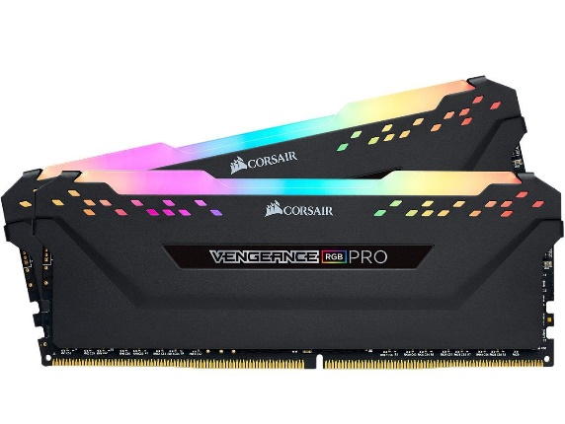**Corsair:**

**Name** : **CORSAIR Vengeance RGB Pro**

**Size**  **: 8G**

**RAM type** : **DDR4**

**Pins**  **: 288-pins**

**Price** : **$54.99USD**

1. **G.Skill:**

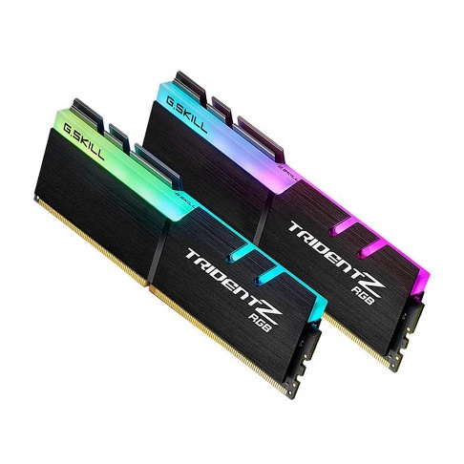

**Name** : **G.skill Trident Z RGB**

**Size**  **: 32GB**

**RAM type** : **DDR4**

**Pins**  **: 288-pins**

**Price**  **:139$**

**3.Mushkin:**

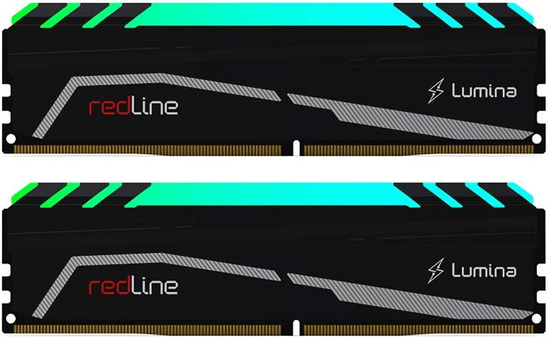

# Name : Mushkin Redline Lumina

# Size : 8GB

**RAM type** : **DDR4**

**Pins**  **: 288-pins**

**Price**  **:59$**

**4.Micron:**

# Name :Micron Technology

# Size : 8GB

**RAM type** **: DDR4**

**Pins**  **: 260-pins**

**Price**  **:24$**

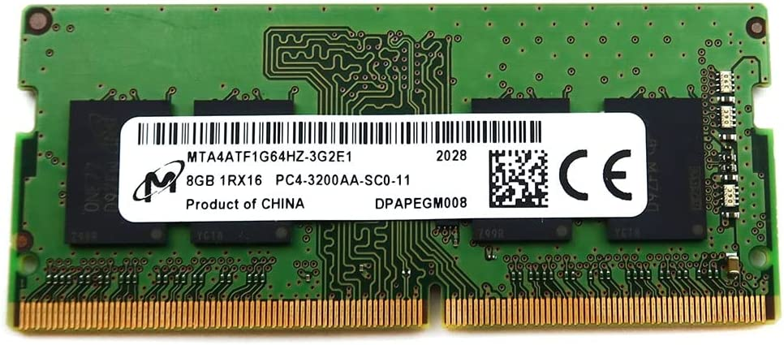

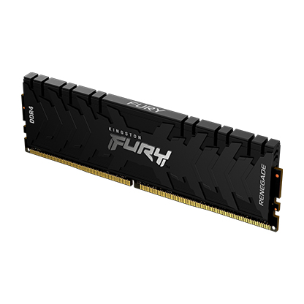

**5.Kingston:**

# Name : Kingston FURY

# Size : 16GB

**RAM type** **: DDR4**

**Pins**  **: 288-pins**

**Price**  **:50$**

**6.XTremeDDR:**

# Name : VisionTek OCPC Xtreme

# Size : 16GB

**RAM type** **: DDR5**

**Pins**  **: 288-pins**

**Price**  **:164$**

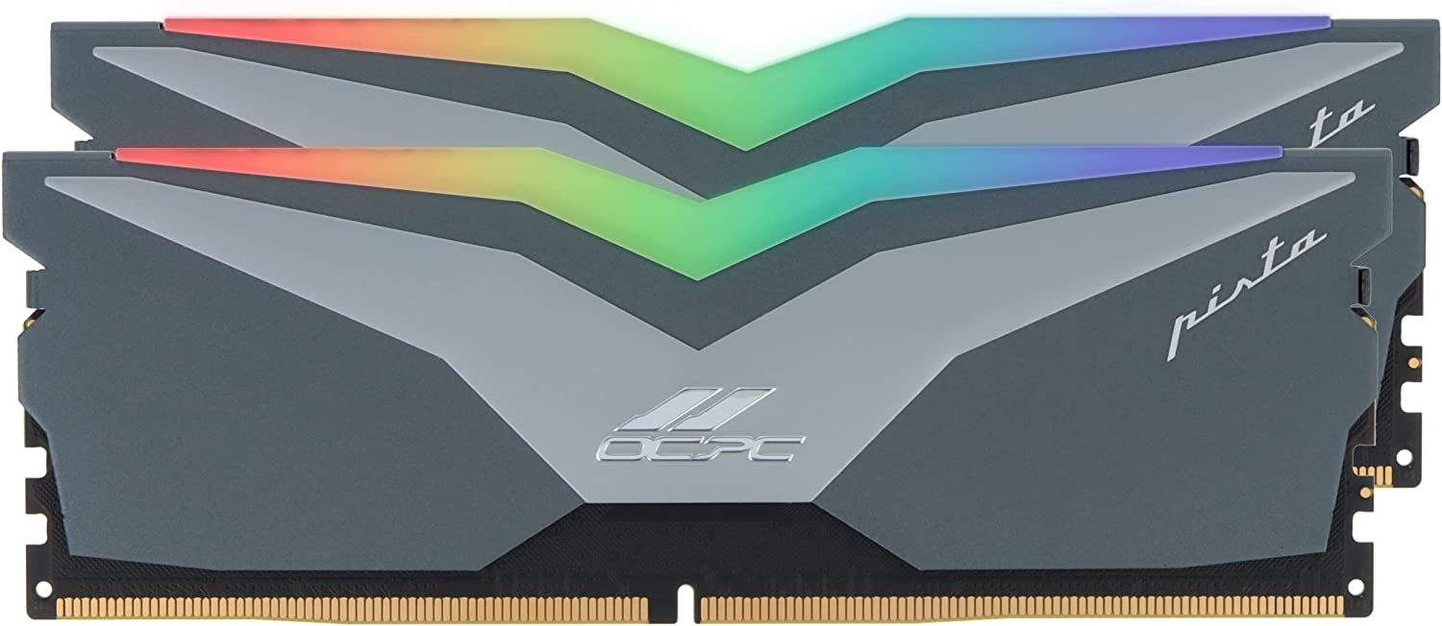

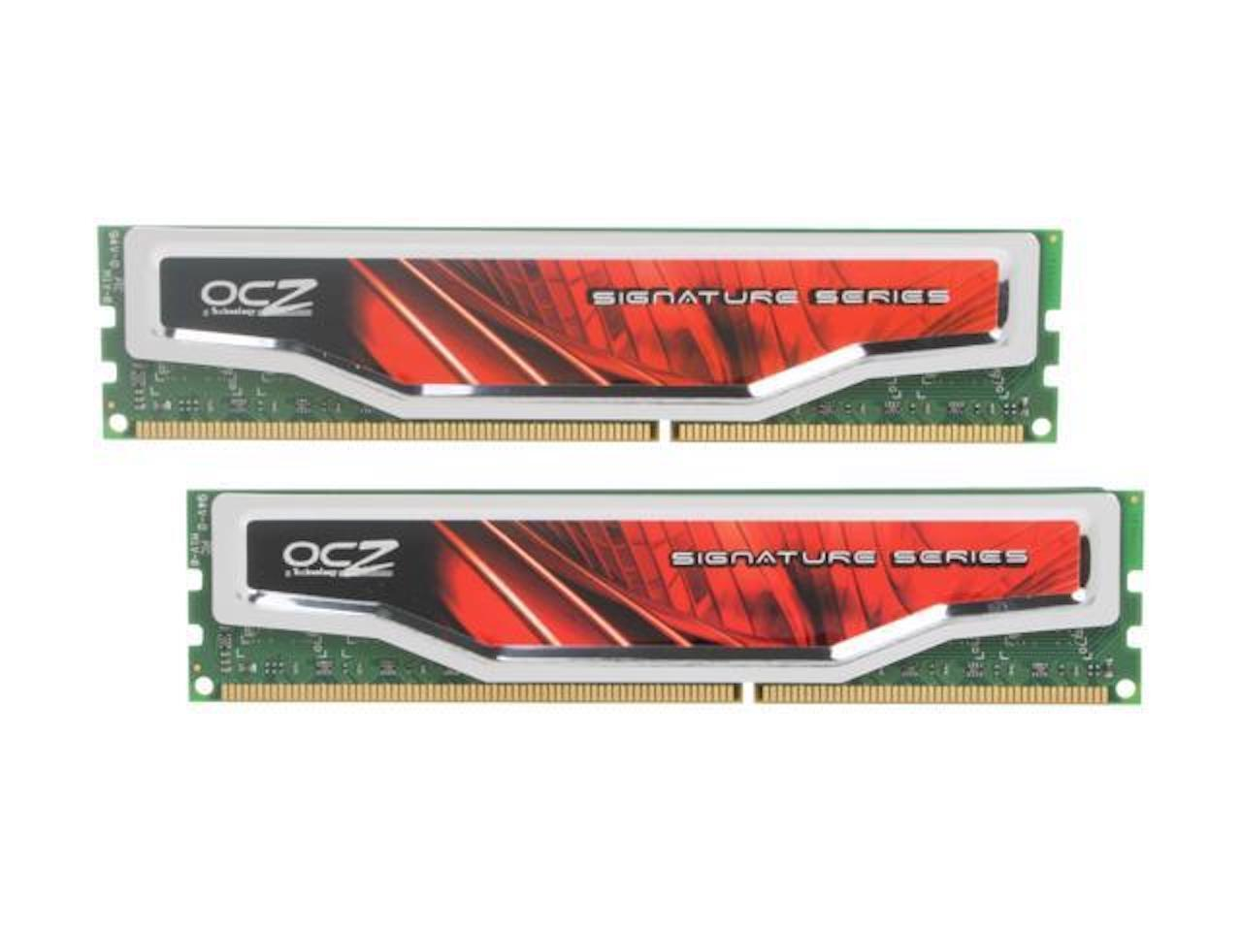

**7.OCZ:**

Name :  **[OCZ Signature](https://www.ebay.com/itm/334529819802?hash=item4de387f49a:g:fQMAAOSwxN9i9Tkt&amdata=enc%3AAQAHAAAA0NkGCkWHxpHUITEuqbhur55tZuJ2LgK919nm30ap0H79gnNMCs2FHAXN7gTnu0%2BYcwamDd6dpiaYq18E585FMJ7l8JA2U4RR%2F6RjcY2LfLd1pPBZ81ieC7FDOzRF8al2UY%2FllB14pCr9QGafpkVl4u%2Bou8tlW3t4RsfaMXv7h1xv13jO1t5zYphuoK4CL9bSMoAWCvAJtxnlIRKhRtL4QYw1xlpb5%2B9NM0lUjWnsXCInMAEsPhjewLe5rocpzLB2Lqmdli7lT2gWLu5q1RrSaxc%3D%7Ctkp%3ABFBM5r-Cn91h" \t "_blank)**

# Size : 4GB

**RAM type** **: DDR3**

**Pins**  **: 240-pins**

**Price**  **:24$**

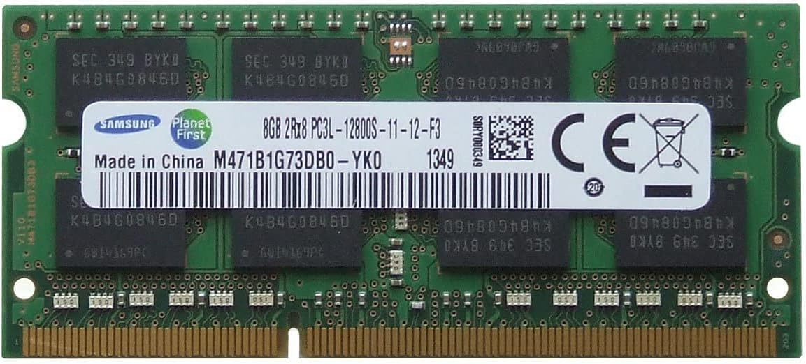**8.Samsung:**

# Name : Samsung Original

# Size : 8GB

**RAM type** **: DDR3**

**Pins**  **: 204-pins**

**Price**  **:46$**

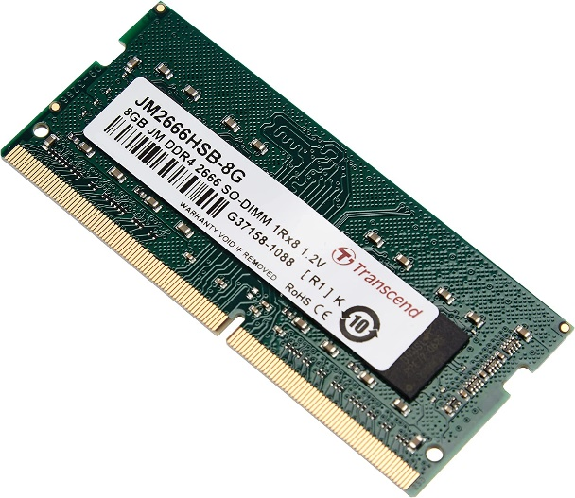 **9.Transcend:**

# Name :Transcend

# Size : 8GB

**RAM type** **: DDR4**

**Pins**  **: 260-pins**

**Price**  **:39.86$**

**10.Hynix:**

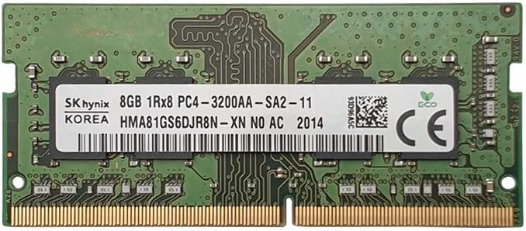

# Name :SK Hynix

# Size : 8GB

**RAM type** **: DDR4**

**Pins**  **: 260-pins**

**Price**  **:22$**